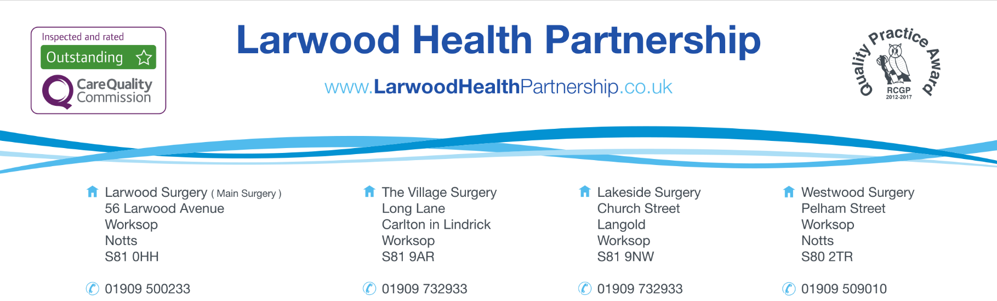

18+
REQUEST FOR AUTISM/ADHD REFERRAL

All referrals for ADHD and/ or Autism assessment and diagnosis must be done by a Neurodevelopmental specialist. The GP surgery is happy to forward the referral request for you. A GP appointment is not required; however, we do need some information from you. Once you have chosen your Service Provider from the list, please complete this form and we will process your referral for you.
The Service Providers do ask that we supply additional clinical information, such as regular medications, recent blood tests, or diagnoses. Please confirm that you are happy for us to supply this additional information in the consent form on the last page.
Please be aware that if you do not consent to us sharing this information, we will be unable to send the referral.

SECTION 1 | Personal Details | Complete: | -

Title |  | Birth Date:
Full Name
Address
Postcode
Mobile Number |  | Home Number
Email Address

I consent to receiving communications via:

SMS Messages: |  | Email Messages: |  | Voicemail Messages

Preferred method of contact? (We recommend SMS)

Please be aware that if you share your telephone numbers or email address with another person, sensitive information may be seen by someone other than yourself. Please let us know if you are being coerced into sharing your information.

SECTION 2 | Referral Details | Complete: | -

You can choose to be referred to the main NHS service for this assessment, known as NeSS. However, you can be referred to an alternative, approved provider via the Right to Choose pathway should you feel this is more appropriate for your needs.

A list of these providers can be found on the Larwood Health website. Please check, choose and confirm your selection below.

Please specify whether you would like a referral for ADHD, Autism or Both.

Please check that your chosen organisation accepts referrals for the condition. Not all organisations do one or both.

Organisation Name
ADHD or Autism | Choose an item.

SECTION 3 | Childhood History | Complete: | -

Describe any difficulties with attention, concentration and memory. e.g. being easily distracted, struggling to concentrate, difficulties following conversations, forgetting appointments or plans, not following conversations, forgetting and losing day to day items.

Describe any times you have experienced Impulsivity and restlessness. e.g. experiencing high levels of impatience and frustration, risk taking behaviour, using substances, poor sleep, racing thoughts, struggling to relax or sit still and fidgeting a lot.

3) Please comment on what impact these difficulties have had on your life. (home, work, education, friendships, relationships, risk-taking, money management etc):

SECTION 4 | Adult History | Complete: | -

Describe any difficulties with attention, concentration and memory. e.g. being easily distracted, struggling to concentrate, difficulties following conversations, forgetting appointments or plans, not following conversations, forgetting and losing day to day items.

Describe any times you have experienced Impulsivity and restlessness. e.g. experiencing high levels of impatience and frustration, risk taking behaviour, using substances, poor sleep, racing thoughts, struggling to relax or sit still and fidgeting a lot.

3) Please comment on what impact these difficulties have had on your life. (home, work, education, friendships, relationships, risk-taking, money management etc):

SECTION 5 | General History | Complete: | -

What is your first language?
Do you have an intellectual disability, or diagnosis of global developmental delay? | Choose an item.
Are you preverbal or nonverbal? | Choose an item.
Do you have a head injury or neurological condition which has left you with significant cognitive impairment? | Choose an item.
Do you post a risk to yourself or others? | Choose an item.
Have you recently self-harmed or have suicidal thoughts? | Choose an item.
Have you recently self-harmed or have suicidal thoughts? | Choose an item.
Have you had any involvement with safeguarding services? | Choose an item.
Have you recently self-harmed or have suicidal thoughts? | Choose an item.
Have you recently been admitted to an acute mental health inpatient service? | Choose an item.
Have you had any involvement with drug/alcohol services? | Choose an item.
Do you have a history of disordered eating? | Choose an item.
Do you have a history of psychosis or have you had a recent episode? | Choose an item.
Have you recently self-harmed or have suicidal thoughts? | Choose an item.
Does your patient have a hearing or visual impairment? | Choose an item.

SECTION 6 | ADHD Self Reporting Scale ADHD Only | Complete: | -

If you are requesting an ADHD assessment, please complete the ADHD Self Reporting Scale.

You can download the ADHD self reporting scale here:

 | https://www.larwoodhealthpartnership.co.uk/downloads/ASRS.docx

SECTION 7 | Autism AQ-10 Autism Only | Complete: | -

If you are requesting an Autism assessment, please complete the AQ-10 form.

You can download the AQ-10 form here:

https://www.larwoodhealthpartnership.co.uk/downloads/AQ10.docx

SECTION 8 | Consent | Complete: | -

I confirm that I am formally requesting that Larwood Health Partnership refers me to the provider named in Section 2 for a neurodevelopmental assessment.

I confirm that I authorise Larwood Health Partnership to provide the following to the chosen provider:

- Summary Care Record
- Current medication list
- Information contained in this form
- Relevant documents from your medical record
- AQ10 form if provided
- ASRS form if provided

Full Name
Signature |  | Date

Relationship to patient (if signing on their behalf)

