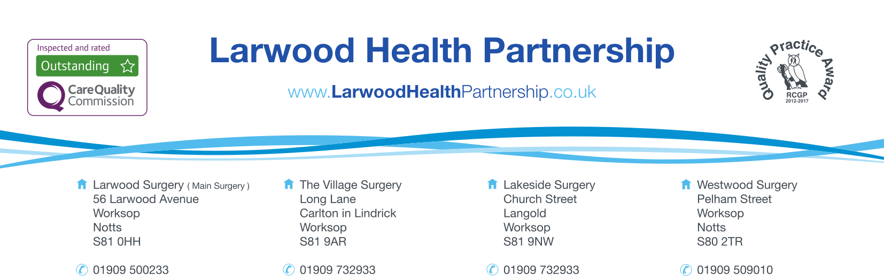

CHANGE OF GENDER CONSENT FORM

SECTION 1 | Personal Details | Complete: | -

Title |  | Birth Date:
Current Name
Address
Postcode
NHS Number

This consent form authorises the NHS to process your request to amend the gender marker on your medical records. As part of this process, a new NHS number will be issued, and your medical history will be transferred to the updated record. This ensures continuity of care while respecting your identity.

New Name
New Gender

SECTION 2 | Acknowledgements and Agreements | Complete: | -

- Identity Verification:
  - I confirm that I am requesting a gender amendment to my medical records to reflect my affirmed gender.
  - I understand that additional documentation (e.g., a Gender Recognition Certificate, deed poll, or other supporting evidence) may be requested to verify my identity.

- Issuance of a New NHS Number:
  - I understand that this process will result in the generation of a new NHS number.
  - I acknowledge that my medical history will remain linked to my care and transferred to the new record.
- Data Protection:
  - I understand that my personal information will be handled in accordance with NHS confidentiality and data protection policies.
  - I give consent for my information to be shared with relevant healthcare professionals and administrative teams as required to complete this process.
- Accuracy of Information:
  - I confirm that the information I have provided is accurate and complete to the best of my knowledge.

SECTION 3 | Patient Consent | Complete: | -
I, the undersigned, give my consent for the NHS to amend my gender on my medical records and issue a new NHS number as part of this process.
Full Name
Signature |  | Date

 | SECTION 4 |  | Further Information
 |  | For more details about the gender amendment process, please visit the https://pcse.england.nhs.uk/services/adoption-and-gender-reassignment/ or contact your GP practice.
 |  | If you are changing gender, please note that a new NHS number will be assigned, and your medical records will be transferred to a new record. The LGBT Foundation provides some helpful resources for your rights as a trans patient: https://bit.ly/40mLa92

NHS Use Only

Received by |  | Position
Date |  | Documents Verified

